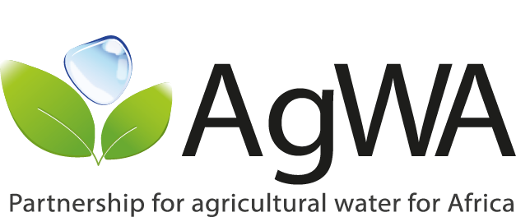
AgWA Steering Committee/Partners’ Meeting
March, 18-19th 2014, Addis Ababa, Ethiopia
SUMMARY OF KEY ISSUES RAISED AND WAY FORWARD

1. Key issues to consider on AgWA’s thematic scope of work
  - Smallholder (family farming)/ poverty reduction
  - Rainfed systems
  - Multiple use services
  - Ecosystem services approach
  - River basin approach and River basin organizations (RBOs) as partners
  - Emphasize AgWA’s role on AWM beyond CAADP (i.e. improving water use efficiency, enhancing water productivity, etc)

2. Way forward. AgWA secretariat and partners to work on the following:
- AgWA vision
- Mapping of actors / stakeholders for CAADP implementation. To use current structures as much as possible (RECs/CAADP FPs)
- Criteria for country selection in proposals
- Results based Framework
- On partnership’s governance
  - To prepare a Constitution (defining roles of members, who gets in the Steering Committee and for how long)
  - Definition of application process / form to become part of the Steering Committee (SC) and reaching out to members.
  - Work on legal status: to hire a legal adviser to assess pros and cons of different alternatives of becoming a legal entity.
- On resource mobilization
  - To work together with ARID and CILSS on a proposal on Knowledge-sharing in Sahel to be funded by the World Bank.
  - Establishing a consortium with partners to apply for funds for specific activities.
  - Undertaking scoping on resources
- AgWA, together with CARE, will work on materializing element 6 in Basket Fund (Biannual publication of the state of the art of AWM in Africa) and event co-organisation
- AgWA, together with WaterNet, will organize a joint session in the WaterNet/WARFSA/GWP-SA Symposium to be held in Malawi in October 2014
- AgWA will lead the creation of a Taskforce for the follow-up of the Eastern Africa Sub-regional Workshop on Addressing the Challenges of Water Scarcity in East Africa and Strengthening Resilience to Drought. In particular to:
  - Clarify taskforce(s) role and ToRs as committee develops its governance structure (FL to lead)
  - Link to SC and non-SC members, potentially in development of taskforce(s)
  - Action points under the Taskforce should be re-examined by the SC

